**DAY -3 ESTIMATE (2 HOUR)**

**20 MAY, 2020**

**Introduction Version Control System (Git)**

* Practice on the following commands:
  + Git clone

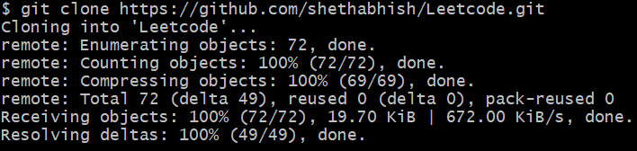

* + Git init



* + Git diff

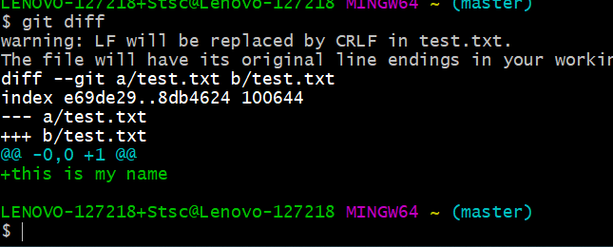

* + Git status

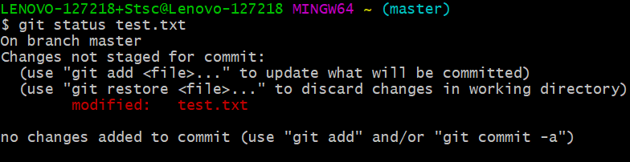

* + Git add . & Git add filename

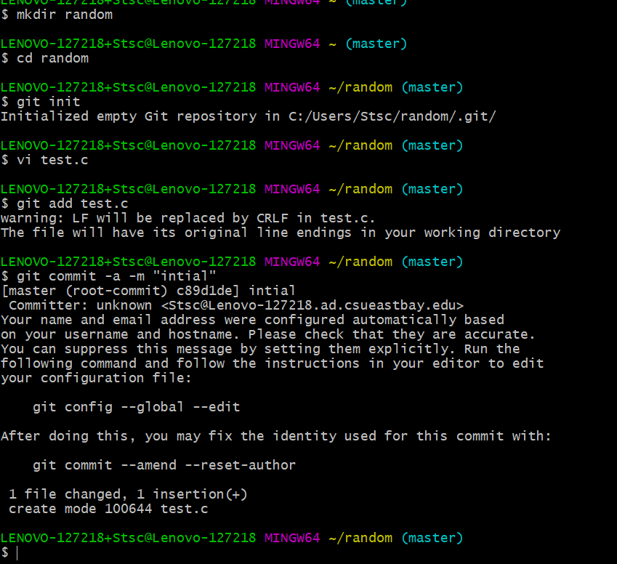

* + Git log

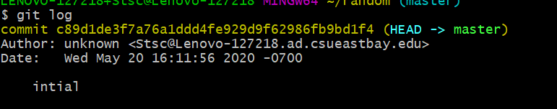

* + Git commit -m “message here”

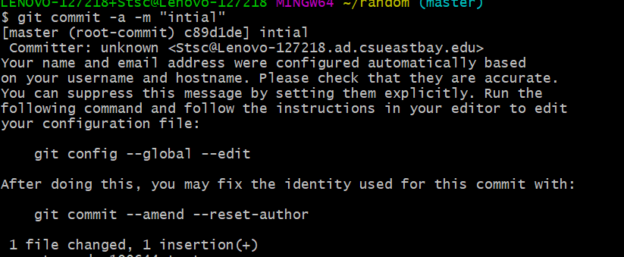

* + Git push

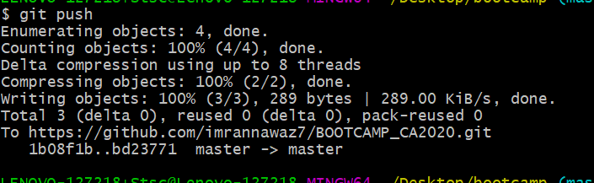

* + Git pull



* + Git reset



* + Git config --global username “usernamehere”



* + Git config --global user.email “emailhere”



**TASK 02:**

* Create an account on GitHub.
* Create a repository with the name “BOOTCAMP_CA2020”.
* Make sure to create this repo with README.md file where you can write necessary information of what this repo is all about.
* Kindly, push both of your assignments as a separate file of each day.

**NOTE:** Files that you have created on Google Doc please download that as doc file (Separate day1 and day2 task in individual file ) and push them on git.

* Learn the concepts of Branching and Merging and create a doc on it. Push the same doc on Git as a separate file named it as day3_task.txt.

**TASK 03:**

* What is an Elastic IP and how it is different from Dynamic IP?

Elastic IP address is a public static IPv4 address which is reachable from the Internet. Basically Elastic IP addresses are used by AWS to manage its dynamic cloud computing services.

A dynamic IP address is an IP address that changes from time to time unlike a static IP address. Most home networks are likely to have a dynamic IP address and the reason for this is because it is cost effective for Internet Service Providers (ISP's) to allocate dynamic IP addresses to their customers.

Instead of one IP address always being allocated to your home network (Static IP), your IP address is pulled from a pool of addresses and then assigned to your home network by your ISP. After a few days, weeks or sometimes months that IP address is put back into the pool and you are assigned a new IP address.

* What is the Client Server Model, Explain in detail?

Client–server model is a distributed application structure that partitions tasks or workloads between the providers of a resource or service, called servers, and service requesters, called clients.[1] Often clients and servers communicate over a computer network on separate hardware, but both client and server may reside in the same system. A server host runs one or more server programs, which share their resources with clients. A client does not share any of its resources, but it requests content or service from a server. Clients, therefore, initiate communication sessions with servers, which await incoming requests. Examples of computer applications that use the client-server model are Email, network printing, and the World Wide Web.